
Semester 2 Examination 2012

Question/answer booklet


MATHEMATICS:
Specialist 3C/3D

Section One
(calculator-free)

Time allowed for this section
Reading time before commencing work: 5 minutes
Working time for section: 50 minutes

Material required/recommended for this section

To be provided by the supervisor
This Question/answer booklet for Section One, and a separate formula sheet which may also be used for Section Two

To be provided by the candidate
Standard items: pens, pencils, pencil sharpener, highlighter, eraser, ruler

Important note to candidates

No other items may be taken into the examination room. It is your responsibility to ensure that you do not have any unauthorised notes or other items of a non-personal nature in the examination room. If you have any unauthorised material with you, hand it to the supervisor before reading any further.

Structure of this examination

 | Number of questions available | Number of questions to be attempted | Working time (minutes) | Marks available
Section One  Calculator—free | 7 | 7 | 50 | 50
Section Two  Calculator—assumed | 11 | 11 | 100 | 100
Total marks |  |  |  | 150

Instructions to candidates

1. Answer all the questions in the spaces provided.

2. Spare answer pages are provided at the end of this booklet. If you need to use them, indicate in the original answer space where the answer is continued i.e. give the page number.

3. Show all your working clearly. Your working should be in sufficient detail to allow your answers to be checked readily and for marks to be awarded for reasoning. Correct answers given without supporting reasoning may not be allocated full marks. Incorrect answers given without supporting reasoning cannot be allocated any marks. If you repeat an answer to any question, ensure that you cancel the answers you do not wish to have marked.
4. It is recommended that you do not use pencil except in diagrams.

Question 1 (7 marks)

Determine the following integrals:

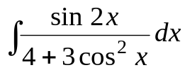
(a) (3 marks)

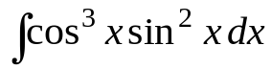
(b) (Let u = sin x) (4 marks)

Question 2 (4 marks)

A function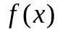 has the following properties:

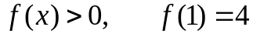 and 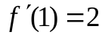

(a) If 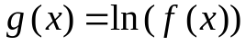, find 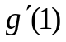. (2 marks)

(b) If 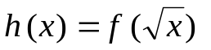 , find 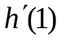. (2 marks)

Question 3 (7 marks)

(a) Prove the following result: 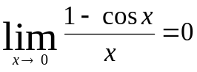 (4 marks)

(b) Evaluate the following limit: 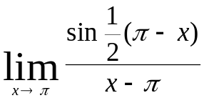 (3 marks)

Question 4 (11 marks)

The points P and Q have position vectors given by i + 2j – 4k and 3i – j + 2k respectively. The line joining PQ cuts the x-z plane at R.

(a) Find the position vector of the point R. (5 marks)

(b) Find the ratio at which the point R divides PQ. (3 marks)

(c) Find the vector equation of the plane that passes through R and is perpendicular to PQ.
(3 marks)

Question 5 (8 marks)

A line segment AB is transformed by a matrix T four times to become CD as shown below.
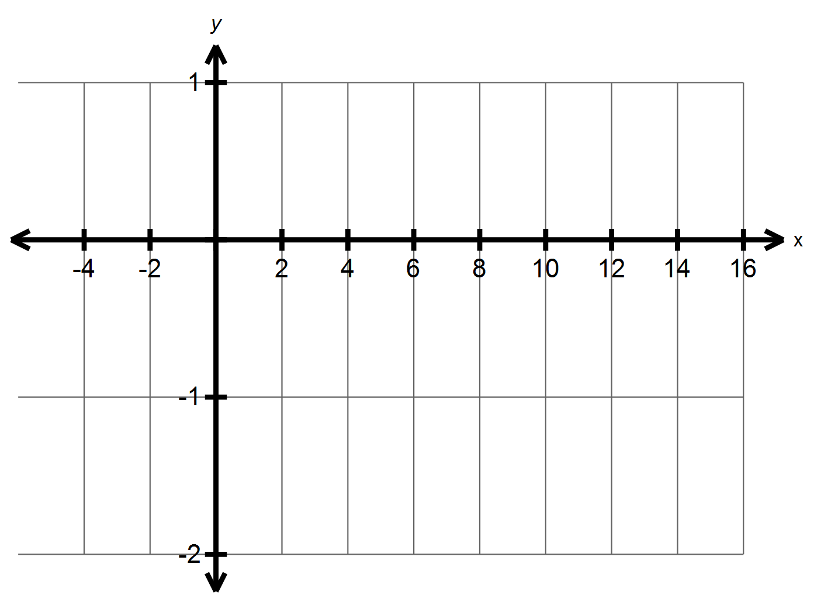
A
B
C
D

(a) The effect of the four transformations by T can be carried out by a single transformation matrix S. State the relationship between T and S. (1 mark)

(b) Determine the matrix S. (3 marks)

(c) Describe the geometric effect of matrix S. (2 marks)

(d) Determine the matrix T. (2 marks)

Question 6 (7 marks)

The complex plane below shows one of the roots of the following equation:

z⁵ = u

where u is a complex number.
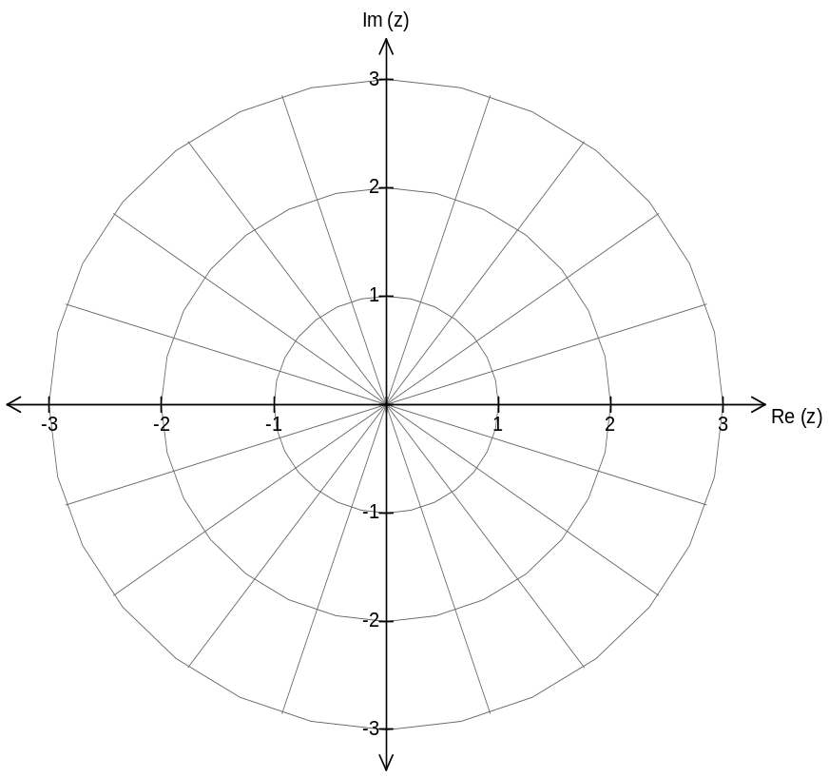

(a) Locate clearly, on the complex plane above, all the other roots of the equation

z⁵ = u

(2 marks)

(b) Determine the complex number u. (2 marks)

(c) Determine the sum of all the roots of the equation z⁵ = u. Show your working/reasoning clearly.
(3 marks)

Question 7 (6 marks)

Prove by contradiction that for any two integers a and b: 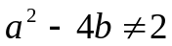.

Additional working space

Question number(s): ________________

Additional working space

Question number(s): ________________

Additional working space

Question number(s): ________________

Semester 2 Examination 2012

Question/answer booklet

MATHEMATICS:
Specialist 3C/3D

Section Two
(calculator-assumed)

Time allowed for this section
Reading time before commencing work: 10 minutes
Working time for section: 100 minutes

Material required/recommended for this section

To be provided by the supervisor
This Question/answer booklet for Section Two. Candidates may use the separate formula sheet from Section One.

To be provided by the candidate
Standard items: pens, pencils, pencil sharpener, highlighter, eraser, ruler
Special items: drawing instruments, templates, notes on up to two unfolded sheets of A4 paper, and up to three calculators, CAS, graphic or scientific, which satisfy the conditions set by the School Curriculum and Standards Authority for this course.

Important note to candidates
No other items may be taken into the examination room. It is your responsibility to ensure that you do not have any unauthorised notes or other items of a non-personal nature in the examination room. If you have any unauthorised material with you, hand it to the supervisor before reading any further.

Structure of this examination

 | Number of questions available | Number of questions to be attempted | Working time (minutes) | Marks available
Section One  Calculator—free | 7 | 7 | 50 | 50
Section Two  Calculator—assumed | 11 | 11 | 100 | 100
Total marks |  |  |  | 150

Instructions to candidates

1. Answer all the questions in the spaces provided.

2. Spare answer pages are provided at the end of this booklet. If you need to use them, indicate in the original answer space where the answer is continued i.e. give the page number.

3. Show all your working clearly. Your working should be in sufficient detail to allow your answers to be checked readily and for marks to be awarded for reasoning. Correct answers given without supporting reasoning may not be allocated full marks. Incorrect answers given without supporting reasoning cannot be allocated any marks. If you repeat an answer to any question, ensure that you cancel the answers you do not wish to have marked.
4. It is recommended that you do not use pencil except in diagrams.

Question 8 (7 marks)

A plane is flying with velocity, 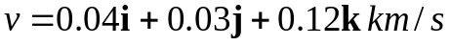 where the unit vectors i, j and k point East, North and vertically upwards respectively.

The initial position of the plane is 20 km South of the airport, at a height of 1.0 km.
Find:

(a) the speed of the plane, (1 mark)

(b) the angle (nearest degree) of ascent of the plane, (3 marks)

(c) the time (whole number) at which the plane is closest to the airport. (3 marks)

Question 9 (12 marks)

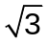A ladder, 2 metres long, has its base on level ground and its top resting against a vertical wall. A ring is fixed 0.5 m from the base of the ladder as shown below. The ladder starts to slip down at a constant rate of 0.1 m/s when it is metres up the wall.

2 m

(a) How fast (exact value) is the foot of the ladder moving away from the wall initially.
(5 marks)

(b) How fast is the ring moving down (vertically)? (3 marks)

2 m

(c) How far is the ladder up the wall when the ring is moving with a speed of 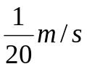.

(4 marks)

Question 10 (9 marks)

A particle moves along a straight line and its displacement x metres from a fixed point O on the line after t seconds is given by:

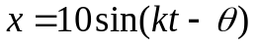

where k and θ are positive constants and 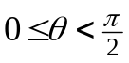.

The particle passes through the point O for the first time after 2 seconds and for the second time after 7 seconds.

(a) Find the values of k and θ. (4 marks)

The particle is furthest away from O the second time when t = T seconds.

(b) (i) Determine the value of T. (2 marks)

(b) (ii) Find the distance travelled by the particle for the first T seconds. (3 marks)

Question 11 (7 marks)

In the figure below, OABC is a trapezium with AB parallel to OC and 2AB = OC. The diagonals intersect at P.

Let 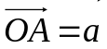 and 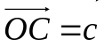
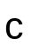
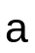
P
O
A
B
C

(a) Express 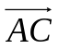 and 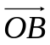 in terms of and . (2 marks)

Let 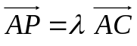

(b) Express 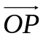 in terms of 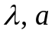 and . (2 marks)

(c) Determine the value of 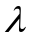. (3 marks)

Question 12 (12 marks)

A population of female bats living in a cave is studied and the following data is collected.

Age (months) | 0 – 6 | 6 – 12 | 12 – 18 | 18 – 24
Initial population | 4500 | 1800 | 900 | 130
Birth rate | 0 | 1.9 | 1.5 | 0.7
Survival rate | 0.5 | 0.8 | 0.4 | 0

The initial female population is represented by a column matrix as shown below.

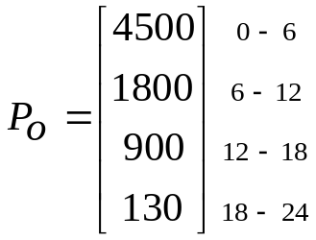

(a) Use a Leslie matrix L to represent the above birth rates and survival rates so that it can be used to calculate the female populations for subsequent years. (1 mark)

(b) Write down a matrix equation that can be used to find the female population for each age group of the bats after 6 months. Do not evaluate. (1 mark)

(c) What is the total female population after 4 years? (2 marks)

(d) Given that the total female population after 5 years is 58890, find the percentage increase in the population every 6 months from year 4 to year 5. (2 marks)

Culling (Harvesting) is carried out for the age group 6 – 12 months at a rate of 30% with the intention of maintaining a stable population. The culling rate affects both the birth rate and the survival rate.

(e) Write down the new Leslie matrix. (1 mark)

(f) If P_{n} is the stable population, write down the population P_{n+1} after 6 months in terms of P_{n} and/or some constants and matrices (if necessary). (1 mark)

(g) Determine whether or not 30% is a reasonable culling rate in order to maintain a stable population. (4 marks)

Question 13 (7 marks)

Prove by mathematical induction that, if n is a positive integer,

Question 14 (9 marks)

(a) Determine the value of A if 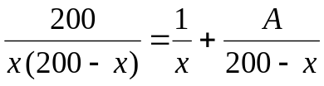 (2 marks)

Let P(t) be the population of a certain animal species. Assume that P(t) satisfies the following equation:

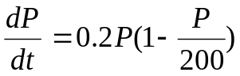 and 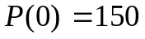

(b) (i) Find P in terms of t. (5 marks)

(b) (ii) What is the long term behaviour of the population P(t)? (2 marks)

Question 15 (10 marks)

The diagram below shows the polar graphs of r = kθ and r = θ + c where k and c are constants and 0 ≤ θ ≤ π.

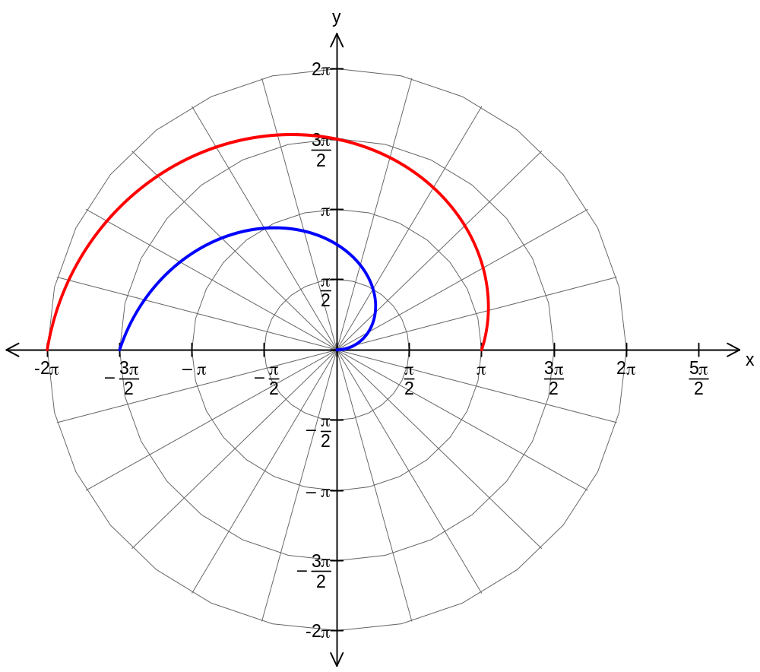

(a) Determine the values of k and c. (4 marks)

(b) Points A(r, α) and B(r, β) are on the graphs of r = kθ and r = θ + c respectively such that they have the same r and the distance between them is 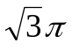.

(i) Show that α satisfies 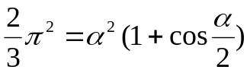 (4 marks)

(ii) Determine the value(s) of α . (2 marks)

Question 16 (9 marks)

The diagram below shows the graph of 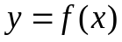 and the graph of its inverse function
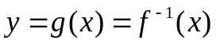

A point P(a, b) is on the graph of . The tangent at P has a gradient m.

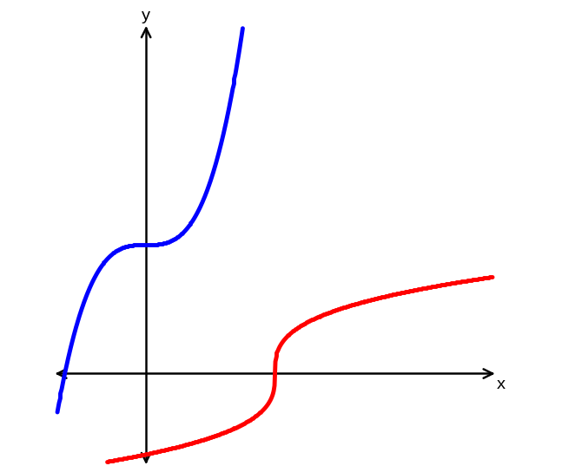
y = f(x)
y = g(x)
P(a, b)
gradient = m

(a) State the value of 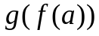. (1 mark)

(b) Show that 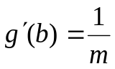. (4 marks)

(c) Find the coordinates of the point of intersection of the tangent at P and the tangent at x = b on the graph of 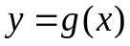 in terms of a, b and m. (Assume m ≠ -1)
(4 marks)

Question 17 (10 marks)

(a) Evaluate 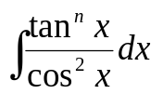in terms of n, where n = 0, 1, 2, ….. (2 marks)

(b) If 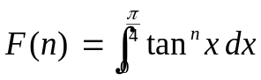 where n = 0, 1, 2 , …..

show that: 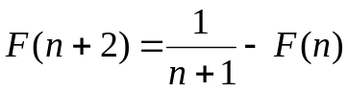
(5 marks)

(c) Using the result from (b), evaluate 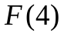. Show working. (3 marks)

Question 18 (8 marks)

The figure below shows a shaded circle satisfied by a complex number z.

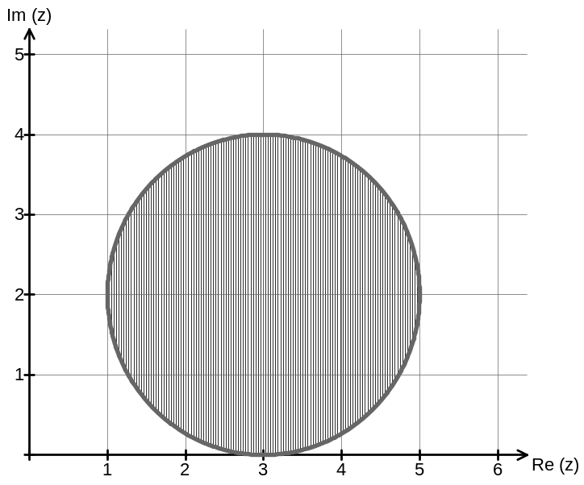

(a) Write an inequality that must be satisfied by z. (1 mark)

(b) Find the maximum exact value of 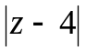. (2 marks)

(c) Find the minimum value (in radians) of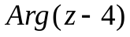. (2 marks)

(d) Find the maximum value (in radians) of 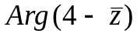. (3 marks)

Additional working space

Question number(s): ________________

Additional working space

Question number(s): ________________

Additional working space

Question number(s): ________________

Additional working space

Question number(s): ________________

Additional working space

Question number(s): ________________

